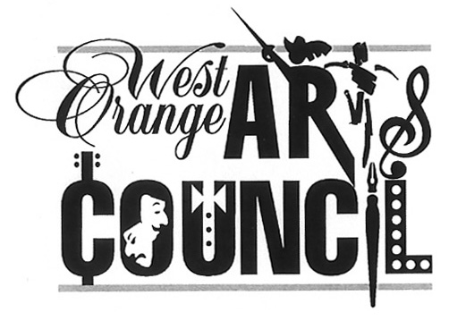
West Orange Arts Council
551 Valley Road, West Orange, NJ 07052
973.325-0151
www.woarts.org
Call for Artists
Festivals, Fiestas & Feasts Exhibit- A Celebration of Culture
Guidelines & Registration Info
Exhibition at the West Orange Arts Center, 551 Valley Road, West Orange, NJ
EXHIBITION PERIOD (Show Dates): September 17-October 22, 2022
Delivery Date: Saturday, Sept. 10, 2022 11am -1pm
RECEPTION: Saturday, October 1, 2022 1-4pm
PICK-UP: Saturday, Oct. 22, 2022 3-4pm
Artists must be WOAC members. Join at: www.woarts.org)
This is WOAC’s exhibit for Hispanic Heritage Month that celebrates the and the multicultural community where we live. All West Orange Arts Council (WOAC) artists who would like to share their perspective are welcome to enter. WOAC provides gallery space, marketing support (calendar listings, press release, social media, and email announcements to contacts). Artists are responsible for being present at the West Orange Arts Center by choosing a time during gallery hours Saturdays from 11am -4pm from Sept. 17-Oct.22, 2022, to assist with welcoming guests to the exhibit by signing up at https://www.signupgenius.com/go/30E0E44ABA62FAAFD0-woac
1. Register & fill out a Goggle forms submission with name of pieces (sizes required). You have the option of submitting a jpeg if you would like us to consider using it for promotion.
https://forms.gle/buHbnDzn7Qk5Szye9
2. Delivery Date: Saturday, September 10, 2022 11am – 1pm
3. Quantity: Up to 3 items per artist-no storage available.
4. Requirements: MUST BE WIRED FOR HANGING! No sawtooth hangers. 2-D only.
5. Size/Wt: Maximum Size — 24” x36” Maximum Weight — 25 lbs
6. Agreement & Inventory Sheet (download from woarts.org): Print and fill out
and bring with you at time of drop-off. Attach labels to the back of your pieces.
7. Commission: WOAC commission is 25% of all sales
8. Pick up Date: Saturday, October 22, 2022 3-4pm (MANDATORY-NO STORAGE)
An artist’s presence connects us to our community and is a crucial part of exhibit operations. Artists are required to represent their work in person at the gallery. Sign up Genius link.
For more info please email: Rey Arvelo, Lisa Suss, Patricia Mitrano, and/or info@woarts.org
This program is made possible in part by funds from the New Jersey State Council on the Arts/Department of State, a Partner Agency of the National Endowment for the Arts and administered by the Essex County Division of Cultural and Historic Affairs.

