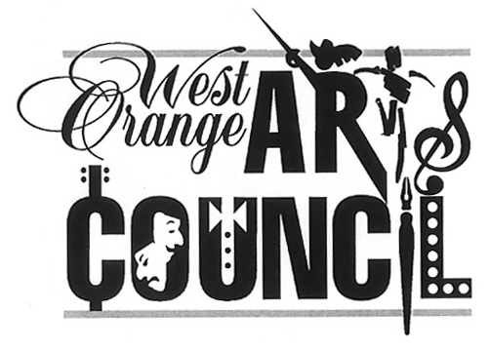
West Orange Arts Council
551 Valley Road, West Orange, NJ 07052
973.325-0151
www.woarts.org
WOAC Festivals, Fiestas & Feasts Exhibit-Sept/Oct 2022
INCOMING ART LOAN AND DISPLAY AGREEMENT

AGREEMENT: The undersigned (“Lender” or “Owner”) lends to The West Orange Arts Council (“WOAC”), 551 Valley Road, West, Orange, NJ 07052, the art and other objects identified below (“Objects”) for the period described below, subject to the terms and conditions set forth herein, and understands and agrees to be bound by all terms and conditions of this agreement with the WOAC. WOAC members only. TO JOIN: https://woarts.org/membership/

EXHIBITION: Festivals, Fiestas & Feasts Exhibit at the West Orange Arts Center, 551 Valley Rd., WO, NJ

DROP OFF: SAT. 9/10 from 11am-1pm EXHIBITION PERIOD: Sept. 17, 2022-October 22, 2022
______________________________________________________________________________________

LENDER: Name: _____________________________________________________________________
Please copy and
paste this info and Home Address: ______________________________________________________________
send in an email
to info@woarts.org City, State, Zip: _____________________________________________________________

Telephone: ______________________________________________________
Your information
will appear in show Email: ____________________________________________________________________
promotions exactly
how it is sent to us Website / Social tags: _________________________________________________________
____________________________________________________________________________________

OBJECTS: Please identify the Objects you are exhibiting by labeling each on the back AND provide a list in a WORD document (for label generation). Include your name, title of artwork, size, medium and price (if offered for sale). Framed objects must be WIRED for hanging. NO SAWTOOTHs

INSURANCE: The Lender understands and agrees that the loan Objects are not and will not be covered by any insurance of the WOAC, West Orange Arts Center, or the Township of West Orange. The Lender assumes all risk and financial responsibility in the event of damage or loss.

RELEASE/WAIVER: The Lender waives and releases the WOAC, West Orange Arts Center, and Township of West Orange and disclaims all such liability for loss or damage to Objects.

COMMISSION: If any Object is sold at or in connection with the Exhibition, the Lender/Owner shall pay and the WOAC shall be entitled to receive and to retain, as a commission, 25% of the Object’s sale price. The Lender/Owner agrees to report to the WOAC all sales of the Objects sold at or in connection with the Exhibition.

ART DROP OFF: Saturday, Sept 10, 2022 11am -1pm
RECEPTION: Saturday, September 24, 2022 1-4pm
PICK-UP: Saturday, October 22, 2022 3PM-4PM

Exhibiting artists must be present & volunteer 1-2 slots at the West Orange Arts Center during Saturdays from 11am -4pm
Sign UP: https://www.signupgenius.com/go/30E0E44ABA62FAAFD0-west
The Lender/Owner represents, acknowledges, and agrees that he/she has full authority and power to make this loan and to enter into this agreement; that he/she has read and understands the terms and conditions set forth in this agreement; and that he/she agrees to be bound by them.

WOAC Festivals, Fiestas & Feasts Exhibit-Sept/Oct 2022
INCOMING ART LOAN AND DISPLAY AGREEMENT

Entry Fee: $15 via WOARTS.org
All participants must be current WOAC Members To join, go to www.woarts.org/membership

TO SUBMIT:

1.ARTWORK Date In: ________________
Lent by:
Lender/Owner/authorized agent (signature) Lender/Owner/authorized agent (print name)
Received by:
WOAC Member Name (signature) WOAC Member Name (print name)

2. LIST OF WORK LOANED (List emailed to info@woarts.org on ______/______/2022)
LIST MUST INCLUDE:
Title of Work: Medium: Size: Price/Value if NFS:

List from:
Lender/Owner/authorized agent (signature) Lender/Owner/authorized agent (print name)
List received by:
WOAC Member Name (signature) WOAC Member Name (print name)
________________________________________________________________________________________________
3.POST-SHOW Date Out: ________________
Picked up by:
Lender/Owner/authorized agent (signature) Lender/Owner/authorized agent (print name)

Released by:
WOAC Member (signature) WOAC Member Name (print name)
The Lender/Owner represents that: the art Objects described above and displayed are his/her original work; that he/she owns the Objects and has the right to display and/or sell the Objects; and that he/she authorizes the WOAC to sell the Objects at the prices specified, unless described as NFS.
___________________________________
Lender/Owner/authorized agent (signature)
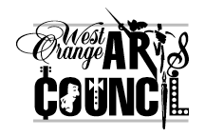  West Orange Arts Council  Inventory #  Your Name  Title  Price / NFS | West Orange Arts Council  Inventory #  Your Name  Title  Price / NFS
~~~~~~~~ Please label your artwork on the back side—cut out and use these labels if needed ~~~~~~~~

