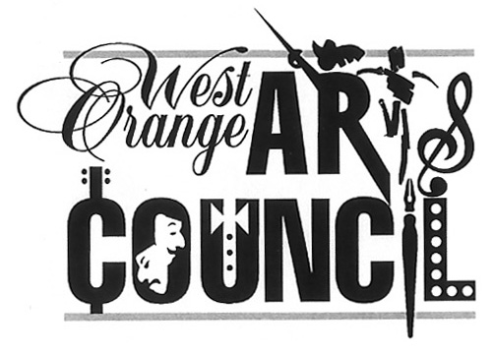
West Orange Arts Council
551 Valley Road, West Orange, NJ 07052
973.325-0151
www.woarts.org
Call for Artists
2022 West Orange Arts Council Pop-Up Exhibit
Guidelines & Pre-registration Info
Exhibition at the West Orange Arts Center
Exhibit opportunity for 3-4 artists available on a first-come, first-served basis
Delivery Date: Saturday, April 30, 2022 11AM - NOON
Pick up Date: Saturday, May 21, 2022 3PM-4PM
Lite Reception: Saturday, May 7 1pm-4pm
West Orange Arts Center, 551 Valley Road, West Orange, NJ 07052
Participation Fee: $25 for WOAC members. Join at: www.woarts.org/membership
Pop-Up will feature 3-4 artists. The WOAC Board will review all proposals. As soon as we have the right combination of artists, the names and emails of exhibiting artists will be sent to all artists to coordinate installation/pick-up, gallery staffing and reception planning.
WOAC provides gallery space, marketing support (calendar listings, press release, social media, and email announcements to contacts). All sales are handled through the WOAC and include 25% commission. Artists are responsible for being present at the West Orange Arts Center on Saturdays (11am -4pm) by signing up at: https://www.signupgenius.com/go/30E0E44ABA62FAAFD0-2022
- Register & fill out submission
(https://docs.google.com/forms/d/1rtyMV0VodSbV-w3rSJCNfLZq_XTNn52VeGk6Mjr1V7s/edit)
Image Submission: Upload up to 2 images (to be used for publicity)
File Name Format: “YourName.PieceTitle.Medium.Size”
File Format: JPEG (1 MB max) (2,000 pixels max. on the longest edge, 72 ppi)
Resizing help: https://bit.ly/2Z2WsSA https://bit.ly/3qQ8VEt https://bit.ly/3lmv1NV
2. Delivery Date: Saturday, April 30, 2022 11am – NOON
3. Requirements: MUST BE WIRED FOR HANGING! No sawtooth hangers. 2-D only*
5. Size/Wt: Maximum Size — 24” x36” Maximum Weight — 25 lbs
6. Agreement & Inventory Sheet (download from woarts.org): Print and fill out
page 2 & 3 (loan agreement and label sheet) and bring with you at time of drop-off.
Cut out labels and attach to the back of your pieces.
7. Commission: WOAC commission is 25% of all sales
8. Pick up Date: Saturday, May 21, 2022 3-4PM (MANDATORY-NO STORAGE)
*3-D art is considered on a case-by-case basis. WOAC not responsible for exhibit platforms
For more information or for questions regarding submission please email curators: Lisa Suss sussme2710@gmail.com, Patricia Mitrano pmitrano@gmail.com, and/or info@woarts.org

